**Classroom Activity: Write a code to create functional components in ReactJS**

**Code:**

File Name: src/App.js

import React, { Component } from 'react';

function App() {

  const text = 'EDUNET FOUNDATION';

  return (

    <div className="App">

      <p> {text}</p>

    </div>

  );

}

export default App;

**OUTPUT:**

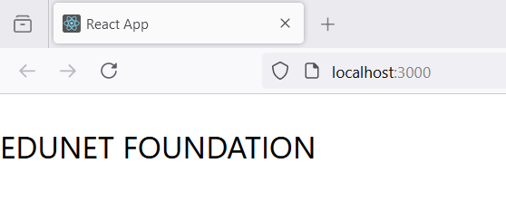

Figure: Output Screenshot

**Execution Steps:**

* Write the above code in App.js File
* Go to VS Code terminal
* Execute following command to run the program: npm start
* This will open your default browser and navigate to http://localhost:3000, where you will see your new React application running.